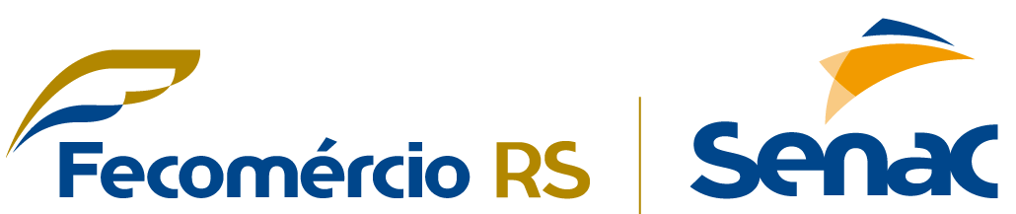
SERVIÇO NACIONAL DE APRENDIZAGEM COMERCIAL - SENAC
SYSTEMS DEVELOPMENT TECHNICIAN COURSE

INTEGRATIVE PROJECT
SUMMIT ESTATE
Teacher: Claudia Maciel
Name: Lucas Augusto Hartmann
Class: DEV3M242

Porto Alegre
2026

1 INTRODUCTION

Real State Control and Management System

General Presentation of the Project

Summit Estate is a complete real estate management system, developed with the goal of organizing and controlling all stages related to the purchase, sale, and rental of properties. The system integrates different types of users, such as administrators, managers, clients, and real estate agents, offering each one functionalities according to their responsibilities.

The software maintains a detailed stock of properties, such as houses, apartments, land, and commercial spaces, each registered with complete information, such as square footage, sale price, location value, number of bedrooms, bathrooms, parking spaces, occupancy status, documentation, owner information, address, attachments, images, and videos.

In addition to real estate management, the software also allows you to manage employees and clients, people involved in the real estate process. It also allows you to create listings for properties, register sales and rentals, view reports such as clients who need to be contacted, company revenue, etc.

Objectives

2.1 General Objective
The software's objective is to simplify, automate, minimize human error, and facilitate information retrieval, while also offering a smooth experience to all users.

The software achieves this by saving company data in the database and displaying it easily to the user with just a few clicks. Clients can also easily view property listings and user and property data can be easily updated.

3 Justificative

This topic was chosen based on my professional experience working for a real estate company, where I use the company's system daily and am familiar with the difficulties users face due to the system or its interface. I've noticed that the system has many limitations and design flaws that was detrimental to the employee’s workflow.
Another reason for choosing this topic was that, besides using the system at my job, I've never had the opportunity to develop a similar system. This project represents a chance to apply my programming knowledge acquired in this course to build software that corrects the problems of the system I use daily at work.
4 Technologies I Used and Why
The project software can be accessed by downloading the program or using the website.
For the development of the software, I used:
Python – I chose Python because it was the first programming language we learned in the Senac course. I found Python quite simple to use, because the language has dynamic typing, which means I don't need to declare a variable as an integer, the language already knows it's an integer when a number is assigned to it.
Textual – Like Python, Textual was an interface framework taught in the course. I chose Textual instead of Tkinter because Textual is relatively new and different. So, it was an exciting experience working with a library different from those that are always used. I found Textual easier and with more ways to build beautiful interfaces. I also liked the use of CSS that Textual offers, because that would prepare me to build the website.
For the development of the website, I used:
HTML - HTML is practically essential for building a website. Being a markup language created for this purpose, this choice was obvious.
CSS - Just like HTML, CSS is fundamental for changing the style of a website. There are some CSS frameworks, but I didn't use any. I wanted to keep it simple and follow the method I learned in the course.
JavaScript - JavaScript is also practically essential for building a website. I used it to obtain the list of PHP properties and display it automatically on the screen.
PHP – I chose PHP because I can do things that JavaScript can't, such as accessing the SQL database and inserting, updating, and deleting data. I can also use PHP to interact with HTML and retrieve data from it.
For both the system and the website, I use this database framework:
SQLite – I decided to use SQLite because it stores data in a local file on the computer. And this file can be used in any SQL software, such as MySQL, MariaDB, Oracle SQL Developer, etc. And, SQLite is easy to use.

